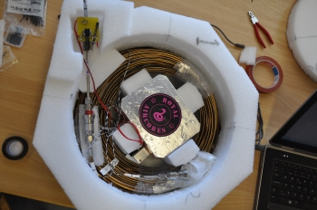
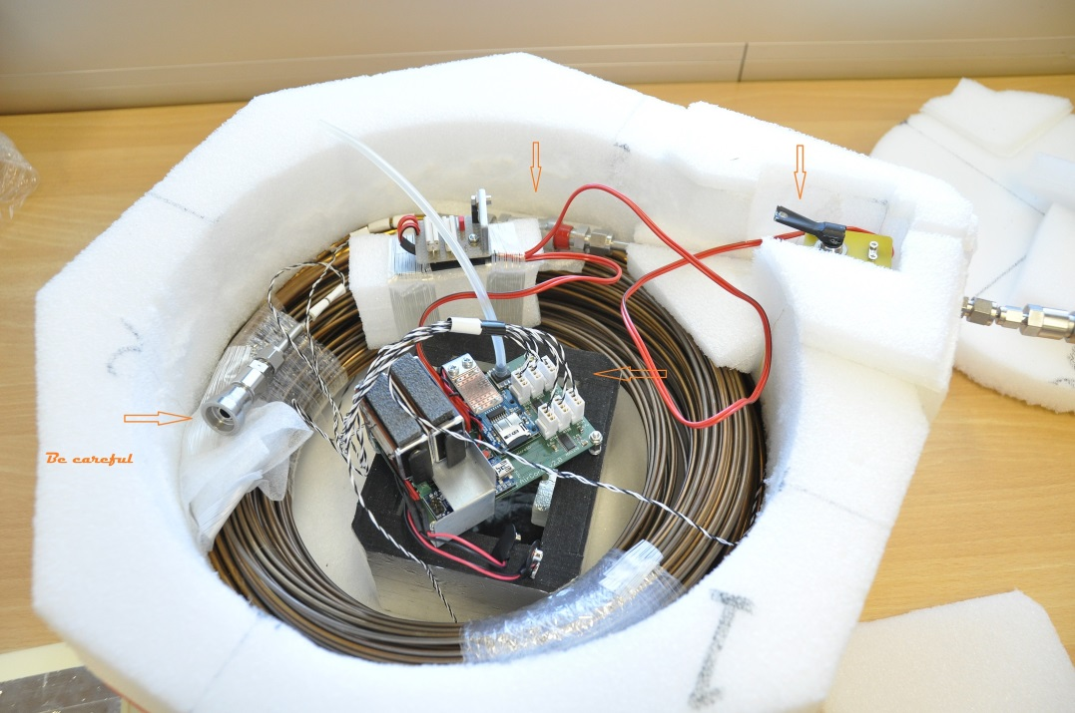
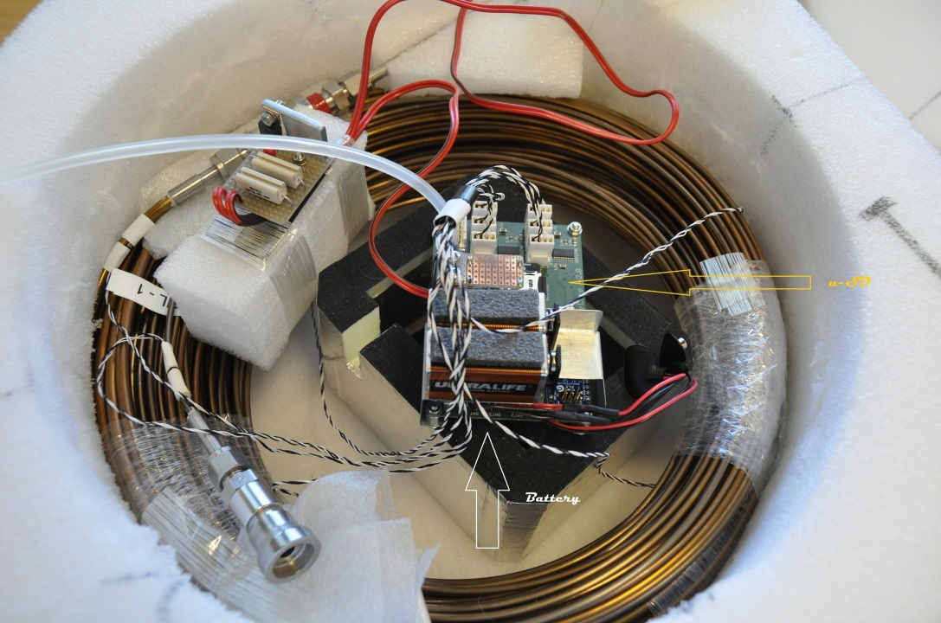
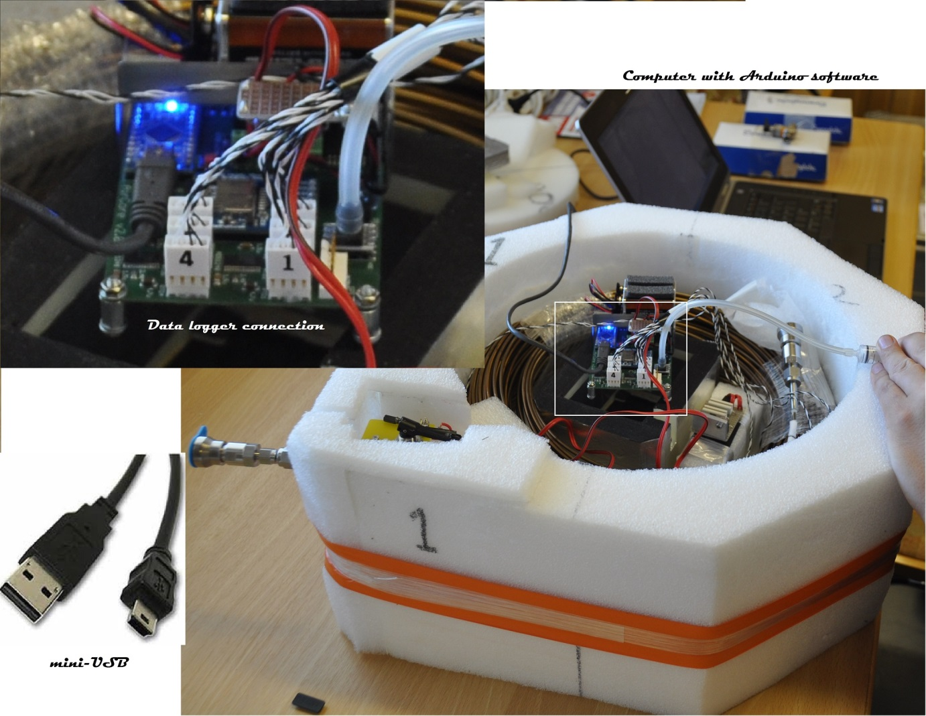
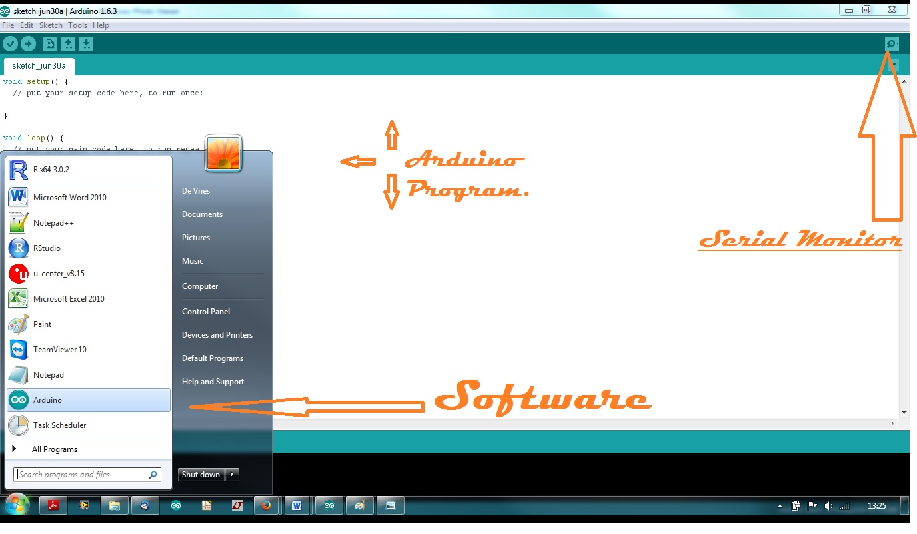
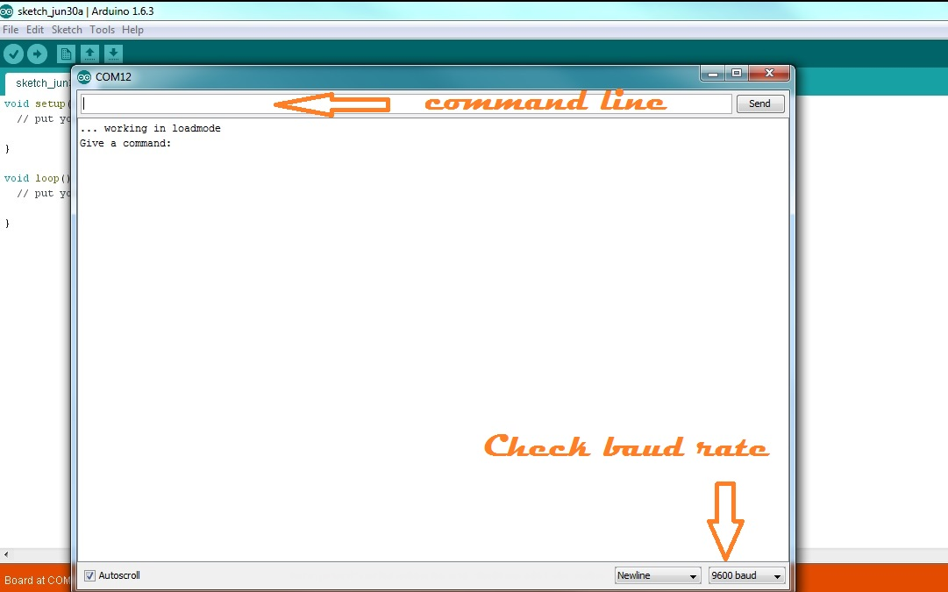
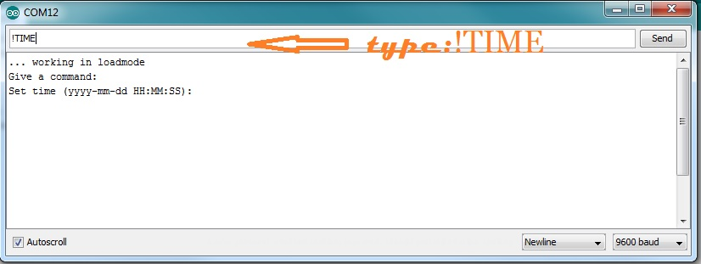
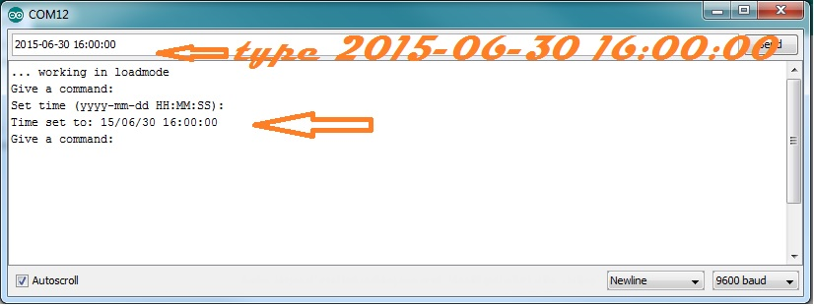
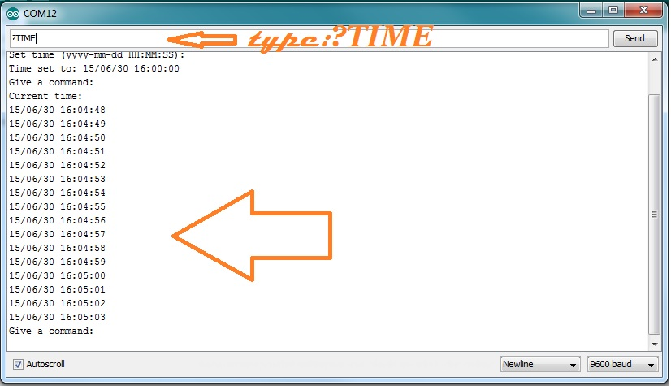
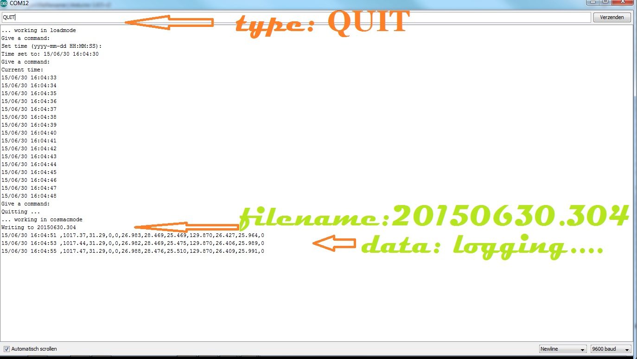
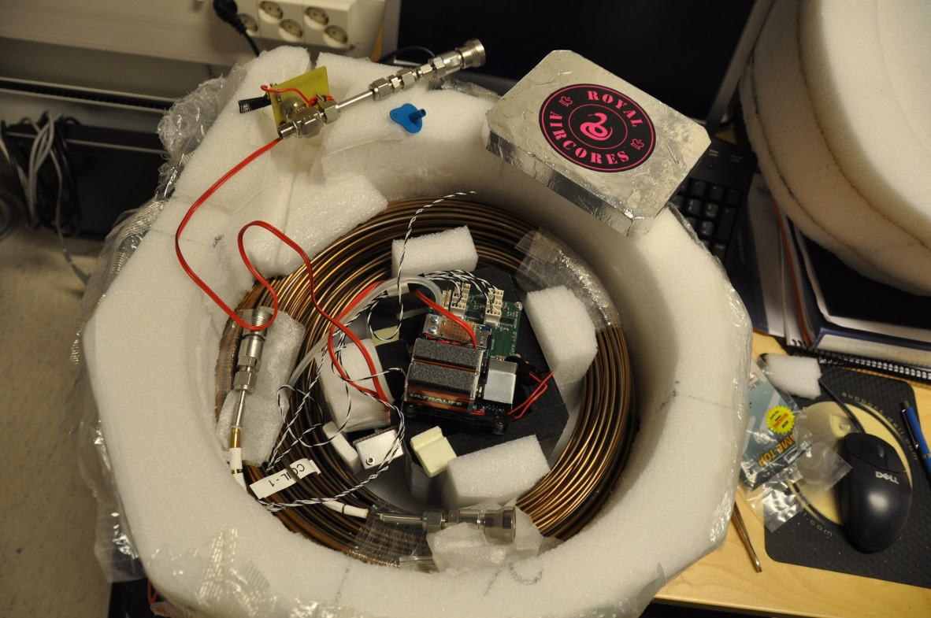
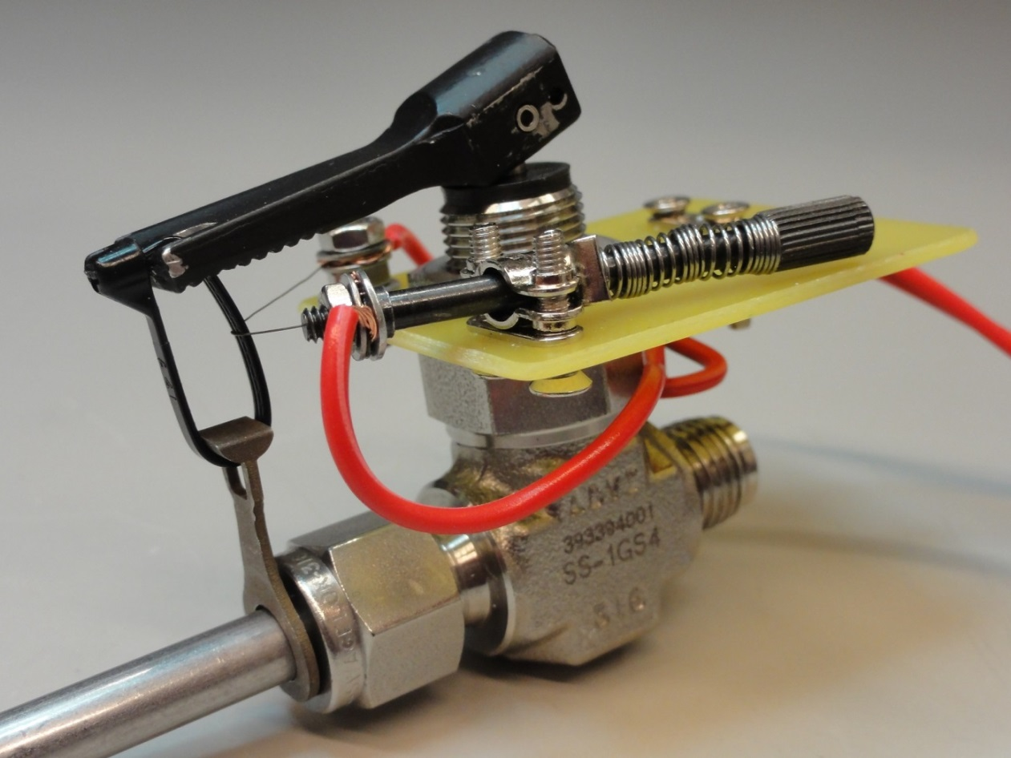
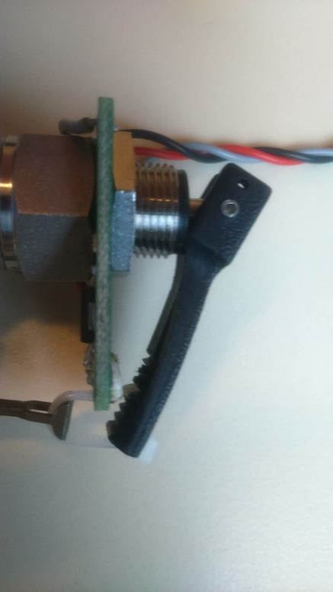
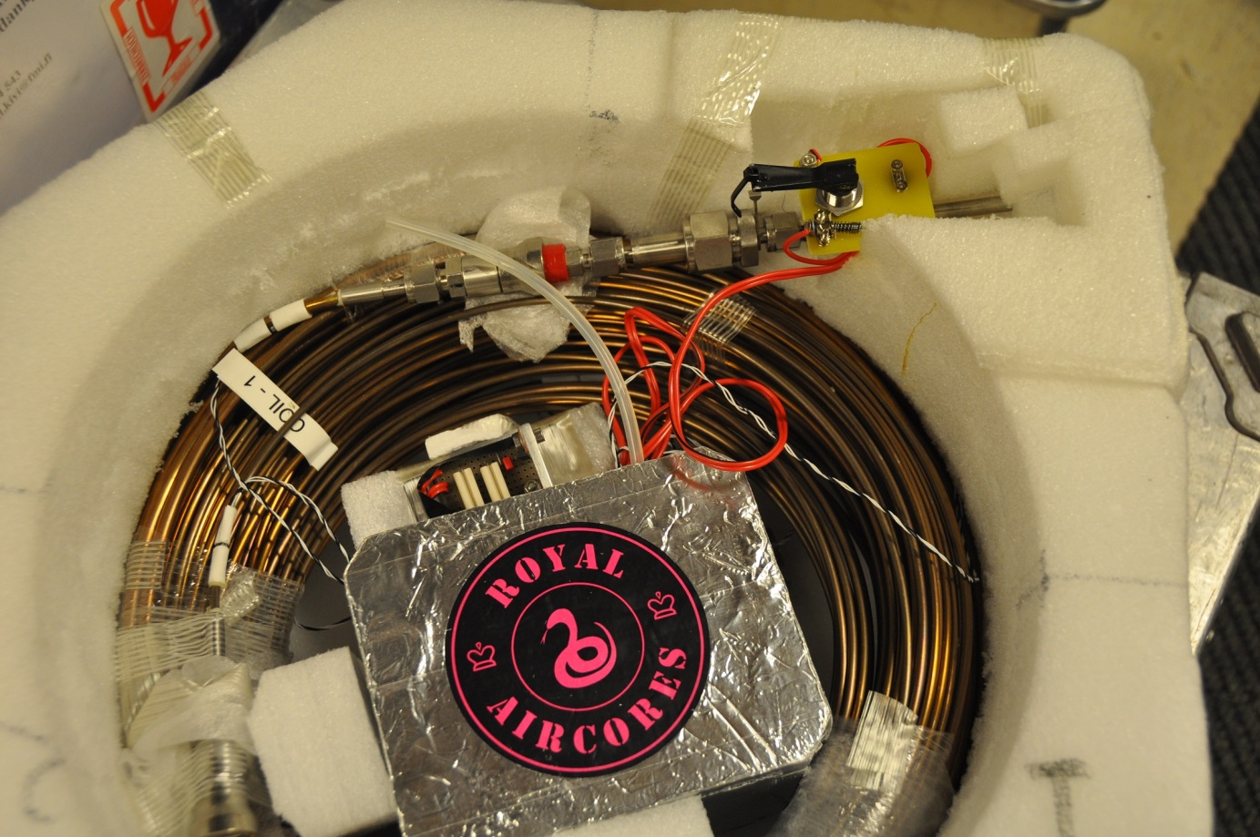
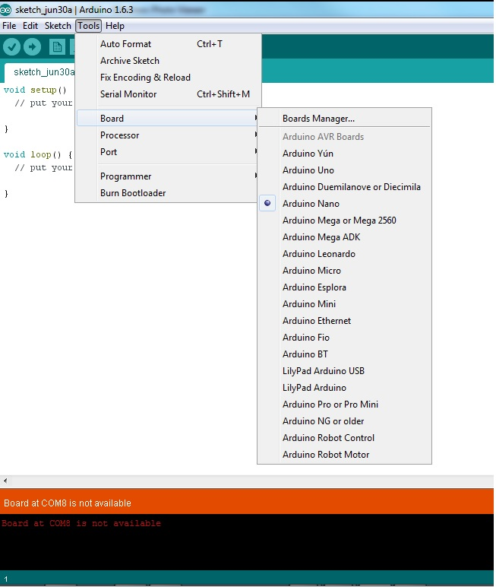
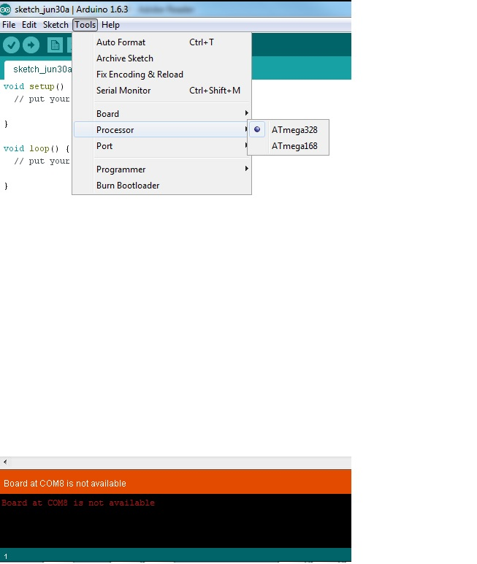
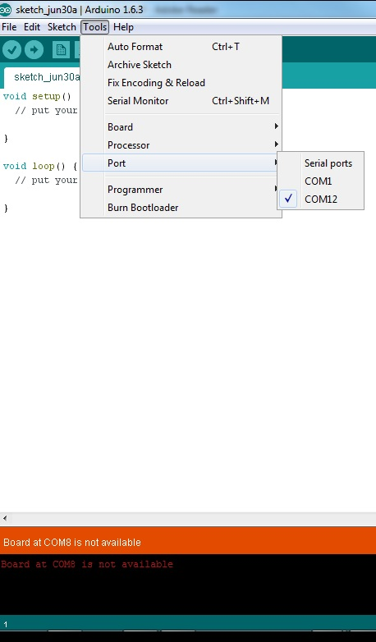
How to use the Data logger Air Pack v0.0
************ AIR pack hardware ************
- Place the air pack on a table.

- Remove the small Box. Remove the data logger out of the box; please, be careful.

- Replace the 24 Volt (pre. Lithium) batteries and check the micro-SD card is present.

- Take the computer with the Adruino software and start it. The computer will be connected with the data logger, by a mini usb cable.

************ AIR core software ************
- Open the Arduino software.
- Open the “SERIAL MONITOR”, on the top left.
- When it is right, the next text will be showed. “…working is loadmode. Give a command: “
- Give command, to set the time: “!TIME”
- Give command, give the time: ”2015-06-30 16:00:00”
- Give command, get the time: “?TIME” . It will replay the time, 15 times.
- Give command, get the time: “!DELAY” . Set delay in mseconde for the time that the pump has to run.

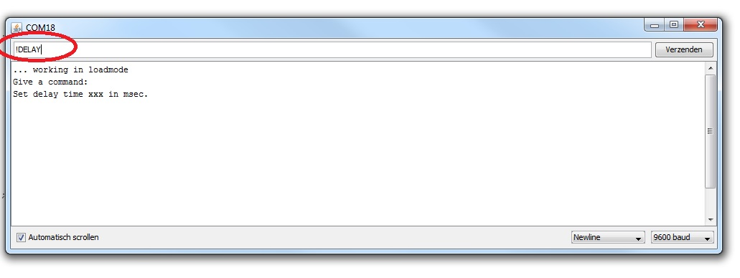
- Give command, get the time: “OPEN_VALVE” . The pump will be tested.
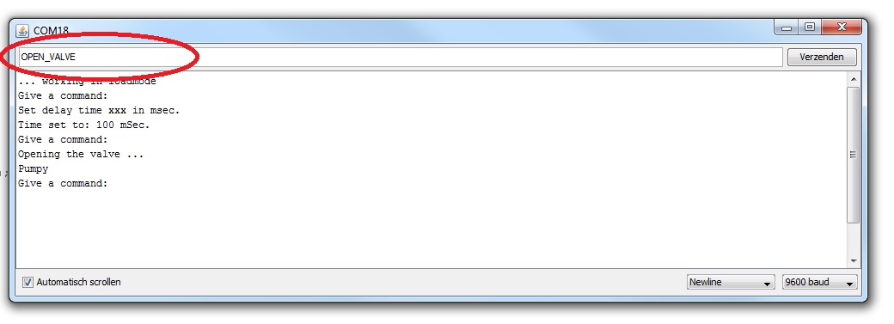
- Give command, “QUIT”. This will stop initialization and start program.
************ AIR core automatic valve ************
- Place all back, data logger is ready.
- Finished. Don´t forget to connect the servo´s.

************ AIR core software problems ************
- Check BOARD : ->Tools->Board->Arduino Nano
- Check Processor: -> Tools->Processor->ATMega328
- Check Port: ->Tools->Port

